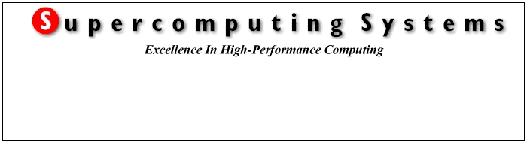

Documentation VHDL Code
PSI Power Supply Controller (PSC)

Composer: | Date: | Changed:
David Müller | 15.7.1999 | Created file
Jenni / Emmenegger /  Tanner | 15.3.2000 | Changes requested
David Müller | 19.4.2000 | New Version released
About this document
The detailed comments about the programming of the FPGA are contained in the VHDL files. This document is to give an overview about the main components and to explain their structure.
The code developed by SCS is documented here. The PWM functionality has been developed by PSI and is documented elsewhere.
Index

1. Design overview 4
2. Usage of addresses and flags 5
2.1. Address space 5
2.2. Definitions of dedicated bytes 7
2.3. Flags 7
2.4. Interrupt requests 7
3. System functions 8
3.1. System state 9
3.2. Output enable, PWM enable 12
3.3. Watchdog counter 13
3.4. Trigger, Interrupt, Reset 13
3.5. Timer 13
4. Communication 14
4.1. General 14
4.2. Link Specification 14
4.2.1. Block structure 14
4.2.2. Loop back, auto echo 15
4.2.3. Data check, error detection 15
4.2.4. Master slave structure 15
4.2.5. Biphase modulation 15
4.3. VHDL implementation – general comments 15
4.3.1. Serial data 15
4.3.2. Block structure 16
4.3.3. Master function 16
4.3.4. Write priority 16
4.3.5. Address space seen from the serial links 16
4.4. VHDL entities serial communication 17
4.4.1. Clock divider 17
4.4.2. Synchronisation of input and reset, inversion of input or output 17
4.4.3. Manchester decoder 18
4.4.4. Serial receiver 19
4.4.5. Serial sender 19
4.4.6. Manchester encoder 20
4.4.7. Break- and preamble-detectors 20
4.5. VHDL entities handling communication blocks 20
4.5.1. Decode block, count communication errors 20
4.5.2. Decode and update status byte 21
4.5.3. Generate echo 21
4.5.4. FIFO 22
4.5.5. Bus interface 22
4.6. Embedding PWM 24
5. FLASH controller 24
6. Test System 26
7. Synthetisation, Compilation Results 26
8. Testing 32
8.1. Testbenches 32
9. References 32

Design overview
An overview of the internal structure of the VHDL code is given in Fig. 1 where it has been divided into 5 functional blocks. All of these have external interfaces to specific IO channels.

- General system functions:
VHDL files:
  - ps_ctrl.vhd
  - types_pwm.vhd
  - types.vhd
  - ps_ctrl_256.sdc (Synplify constraint file)

- ‘RS232 IO’: allows to read and to write on the card using a PC / Laptop.
VHDL files (those marked with a * are instantiated identically in ‘CIO’):
  - sender_par.vhd *
  - receiver_par.vhd *
  - preamble_detect.vhd *
  - status_decoder.vhd *
  - block_decoder.vhd *
  - gen_echo.vhd *
  - clock_div_rs232.vhd
  - sync_serial.vhd *

- ‘CIO’: allows to read and to write on the card from the control system (EPICS).
VHDL files (in addition to those listed in ‘RS232 IO’):
  - break_detect.vhd
  - clock_div_var.vhd
  - rec_manchester.vhd
  - send_manchester.vhd

- ‘System, Trigger/Interrupt/Reset, Watchdog’: controls the status of the board (E.g. is a program running on the DSP? Are outputs enabled?) and handles external trigger/interrupt/reset requests.
VHDL files:
  - watchdog.vhd
  - trig_ctrl.vhd
  - led_ctrl.vhd
  - timer.vhd
  - rec_pwm_fb.vhd

- ‘FIFO, BUS interface’: messages from the serial interfaces to the DSP are written into a FIFO, which the DSP can read. Read and write commands from the DSP to the FPGA are decoded and the data from the FPGA is provided respectively data from the DSP is handed over to the corresponding VHDL block.
VHDL files:
  - bus_ctrl.vhd
  - fifo_ctrl.vhd

- ‘PWM’: The heart of the controller card, where the steering signals for the power converters are generated.
VHDL files:
  - top.vhd
  - swcntrl.vhd
  - integrat.vhd
  - puls_exp.vhd
  - timing.vhd

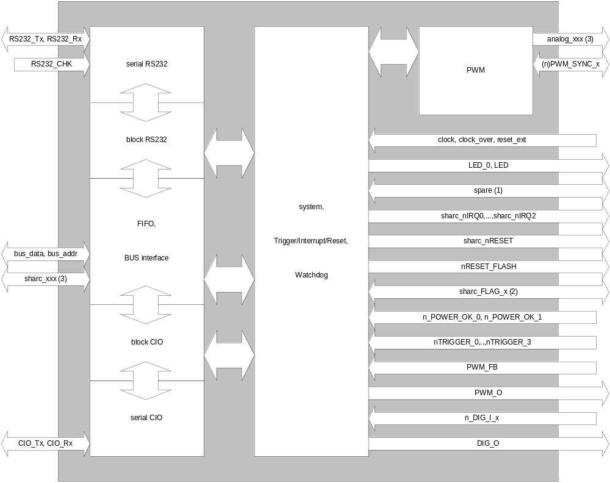

Fig. 1: Overview of the FPGA. The communication blocks (CIO and RS232) have been split into a ‘serial’ part (where serial data is received as bytes and vice versa) and a ‘block’ part where the 6-byte block structure of the communication is decoded.
- Eight spare bits are available. At version numbers greater then 0x10 of the VHDL software, they are defined as inputs.
- Every flag is unidirectional. Some of them are input, others outputs, see section 2.3.
- Sharc_xxx. Control signals of the bus and unused dedicated IO signals of the DSP. See PS_CTRL.VHD for a complete list.

Usage of addresses and flags

Address space
From the serial links addresses 0 to 0xFF can be accessed for read- and write access. Some of these addresses are meaningful for either read or write only as indicated in the following table. Commands on addresses 0 to 3 from the serial links are interpreted by the FPGA. Any other address corresponds to access of the dedicated memory block in the DSP. The address space 0 to 0x1F on the FPGA can be accessed from the local BUS (DSP). A read command from the control system e.g. to address 0x1A does not report the value of 'LIM_LOW' stored in the FPGA but its mirrored value on the DSP.
The addresses have initially been grouped according to the blocks ‘system (SYS)’, ‘communication (COM)’, ‘Trigger/Interrupt/Reset (TRI)’, ‘Timer (TIMER)’, ‘Watchdog (WD)’, ‘digital I/Os (DIG)’, and ‘PWM (PWM)’. With re-allocations of addresses during the implementation phase, that grouping has been somewhat disturbed.
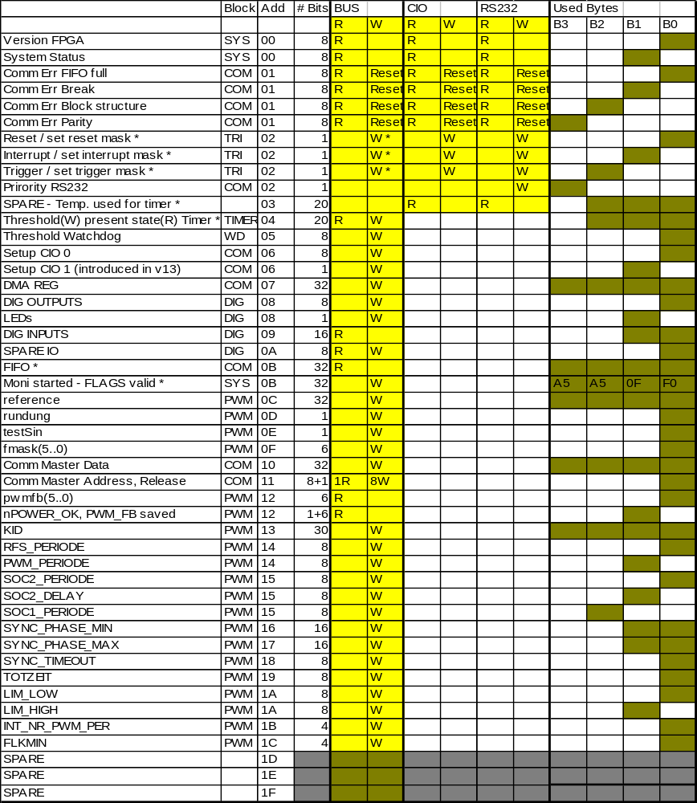
Tab. 1: Address space on the FPGA. For detailed documentation of the different variables, check the according VHDL files.
Comments (*):
- Address 0x2: From the bus the masks can be written, from the serial links the signals can be activated
- Address 0x3, 0x4: Presently the timer can be read from the serial links. As the idea was that only addresses 0 to 3 are interpreted for the serial links by the FPGA, the timer must be read at a different address from the serial link than the address defined previously for the DSP.
- Address 0xB: The same address is used for reading from the FIFO (see Section 4.5.4) and for writing the 'Monitor started - FLAGS are valid now' code (see Section 3.1).

Definitions of dedicated bytes
In general, if less than 8 bits are used from a byte, only the LSBs will be used (i.e. if e.g. 3 bits are used , it will be bit 2 downto bit 0). Bytes containing bits with specific meanings are listed in Tab. 2.

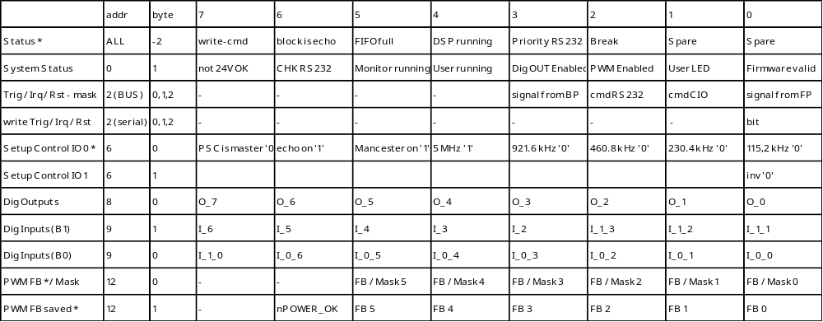
Tab. 2: Definition of dedicated bytes.
Comments (*):
- Status-byte: First byte of data block as defined in [3] and section 4.2.1 (serial links).
- Set-up CIO: Only one of the bits 0..4 should be set, selecting the according frequency. If more then one of the five frequencies are selected at the time, the lowest of the chosen frequencies will be selected. If none of the five bits is set, 5MHz are selected. Recommended default values of the bits are indicated.
- PWM_FB: For version 23 and higher, the ‘filtered’ signals (output of REC_PWM_FB) are delivered. Previous versions: ‘unfiltered’ signals.
- PWM_FB_saved: Values from power supervision and filtered feedback signals are written into registers as long as PWM is enabled. If it is disabled by any reason, the ‘saved’ feedback signals can be used to locate the source of the error.

Flags

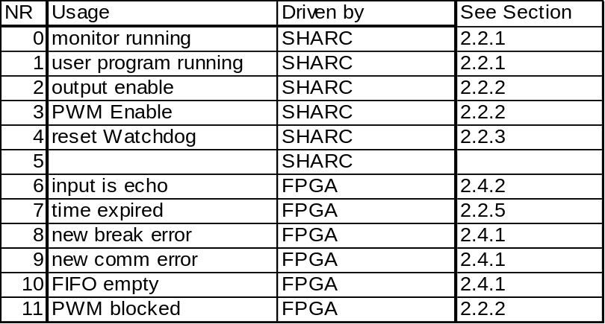
Tab. 3: Usage of flags.

Interrupt requests
Three interrupt levels (plus the 'reset') of the DSP can be activated from the FPGA.
A reset signal from the 5V power survey or the reset switch on the front panel resets the DSP and the FPGA. Resets from any other source reset the DSP only. The highest priority interrupt (irq 2) is not used presently. Interrupt level 1 can be activated by external signals where it is referred to as 'INTERRUPT' (see section 3.4). The lowest interrupt level is activated when a 'TRIGGER' signal has started the timer on the FPGA.

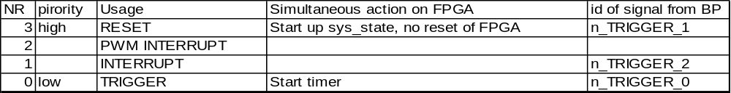
Tab. 4: Usage of SHARC interrupt signals and reset.

System functions

The main system control functions are contained in two main entities with a close interplay:

- watchdog contains 4 processes:
- sys_st: main state-machine for the status of the PSC
- bark: watchdog-counter to detect crashes of the DSP program
- out_stat: state-machine to enable the digital outputs
- pwm_stat: state-machine to enable the PWM outputs

- trig_ctrl (one process with three sub-processes). Handles all trigger- interrupt- and reset-requests from the various sources.

Additional system entities:

- rec_pwm_fb: Records the incoming exernal feedback signals. If they are low (=error) for more than 5 us, the internal feedback signals are changed to the alarm state (low). The internal feedback signals are fed to the entity watchdog, where they are validated by the feedback mask and cause – in case of a validated alarm – a emergency off of the pwn output signals (see section 3.2).

- sync_serial: This entity synchronises the incoming serial data streams and in addition the reset signal (see 4.4.2).

- led_ctrl: Controls the LEDs on the front panel of the card.

- types.vhd: A package rather then an entity. All constants (except for the PWM constants) including default values for the different parameters are defined here, e.g. the version number of the VHDL code, which can be read via the serial links (be careful, that this version number is identical with the one used in the file name).

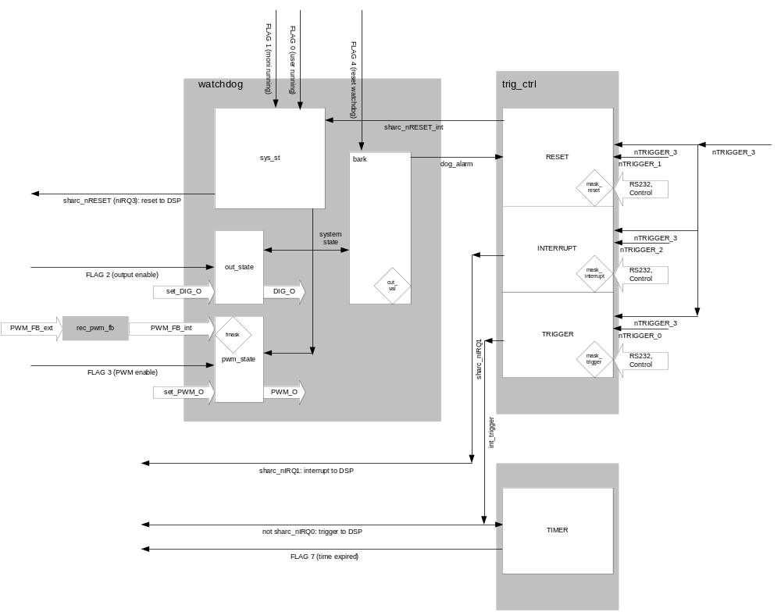
Fig. 2: Schematic view of the system functions. Only the main signals are shown. The main parameters are indicated by the rotated squares.

System state
Different states of the board – including FPGA, DSP, Power supply –are shown in Fig. 3.

The according state machines on the FPGA are called:
- System state
- PWMOUT state
- OUTPUT state
and will be explained in this section.
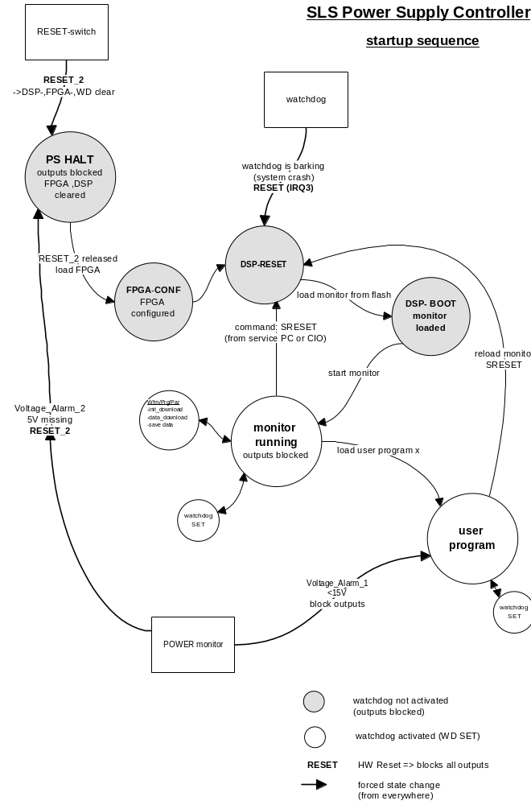

Fig. 3: Different states of the controller card. [M. Emmenegger]

The system state-machine is the main control for the status of the PSC board, the different levels are indicated in Fig. 4. A few clock cycles after removing the FPGA-reset the FLASH-reset is removed and the FPGA checks, whether the 'valid firmware-byte' is correctly set. Only if this is the case, the DSP is started in two steps (SBTS_started = DSP gains control over bus; SHARC_started = 'reset' is removed from DSP).
The state of the FLAGS driven by the DSP is not yet defined at that time and is therefore ignored by the system controller. At the beginning of the monitor program, the 'magic number' 0xA5A50FF0 has to be written once to the address specified in Tab. 1 (it is the same address as used for reading data from the FIFO since writing to the FIFO is not possible anyway). After this writing, the FLAGS are known to be valid until a reset of the DSP occurs and no further writing of the 'magic number' is necessary during normal operation. After writing to the magic number, the system state changes to ‘trans’ from where ‘moni_on’ and ‘user_on’ can be activated by the DSP by setting the according flags. With any transition between ‘moni_on’ and ‘user_on’ the system states goes back to ‘trans’ where the watchdog is not active and no output is possible.
All further transitions between states are steered by the 'monitor running' and the 'user program running' flags from the DSP - and by an eventual reset-signal.

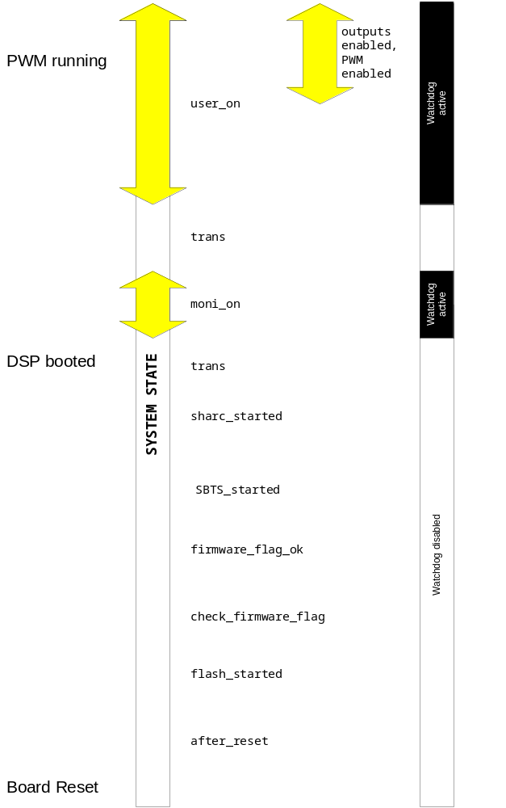
Fig. 4: System states and output states. The watchdog is active only, if monitor or user program are running. Output / PWM enabled is only possible when the user program is running. See text section 3.1 for further explanations.

Output enable, PWM enable
Two independent processes control the digital outputs and the PWM outputs. Both are steered by separate FLAGs from the DSP.
The following safety conditions apply:
- All outputs are blocked if the supply-voltage of the board (24V) drops below 15V or if the system_state is other than 'user_on' (Watchdog released or FLAG 1 cleared).
- PWM outputs are in addition blocked, if an error is indicated on the PWM feedback signals. These errors have to be validated with the according bit in the feedback-mask.

The output and the PWM-output state machines know three states:

disabled,
enabled,
blocked

If enabled outputs are switched off properly by clearing the enable-flag, the state-machine goes back to the disabled state. If the outputs are cut off due to some error-condition, the state-machine falls into the 'blocked' state from where it can only pass to the 'disabled' state, if the 'output enable'/'pwm enable' - flag is removed. After every error, the outputs must therefore be enabled actively again.
If the DSP tries to enable (PWM-) outputs when the safety conditions are not fulfilled, the state machine falls into the blocked state immediately. See also Fig. 5.

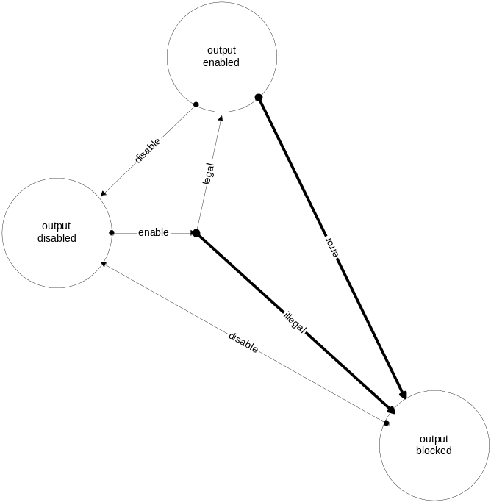

Fig. 5: Output states. Transitions between PWM states are defined accordingly.

Watchdog counter
The counter of the watchdog is set to 0 whenever the system is in a state other than 'moni_running' or 'user_running' or if the 'touch watchdog' flag has changed from 0 to 1. The counter is incremented at 115 kHz (strobe RS232). The cut-value at which an alarm is released, can be programmed from the DSP. The default-value is at its maximal possible value of 255, which corresponds to 2.2 ms. Whenever a reset of the DSP is executed, the threshold is set back to 255 (otherwise a faulty user program – setting the threshold e.g. to 0 – might be loaded into all cards simultaneously, making a reset of the FPGA of all cards necessary.

Trigger, Interrupt, Reset
These internal signals can be activated from different sources:

- nTRIGGER_3 (optical input on front-plate of PSC)
- CIO
- RS232
- nTRIGGER_x from backplane (x=0: TRIGGER, x=1: RESET DSP, x=2: INTERRUPT)

4-bit masks (LSBs of bytes, numbering as above) can be set from the DSP, enabling the corresponding sources to activate the signals. The nTRIGGER_3 signal can be directed to the internal signal trigger, reset or interrupt. If several masks have the bit 0 set, a signal of the optical input would activate e.g. trigger and reset at the same time, which would most probably make no sense at all.
The trigger signals from front- and backplane are edge sensitive and insensitive to spikes shorter then 500 ns.

Timer
A 20-bit counter is started by the trigger command. The timer is incremented at 1 MHz (clock divided by 30). A programmable end-value allows to stop the counter when it reaches the desired value. The stopping is communicated to the DSP by activating the 'time expired' flag. If a new trigger is received before the end-value has been reached, it restarts from zero nevertheless. At a reset of the FPGA, the timer is initialised to zero, the end-value is set to 2²⁰-1 = 1’048’575.

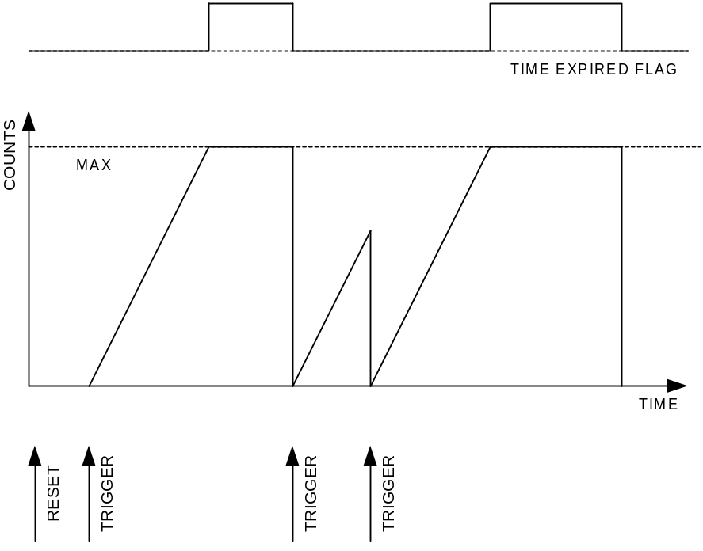
Fig. 1: Behaviour of the timing-counter and of the 'time expired flag'.

Communication

General

Two independent communication streams allow to read and write data to the PSC, an overview is given in Fig. 7 . The optical serial in- and output are designed for the connection to the control system and will therefore often be referenced to as 'CONTROL' or 'CIO'. The second serial connection corresponds to the RS232 standard. Both channels have a very similar structure and share most of the VHDL-entities, which are instantiated twice. Differences will be mentioned at the corresponding places throughout the following sections.
Bytes are asynchronously transmitted in the sequence 'start bit - 8 data bits - parity bit - 1 stop bit'. The parity bit is checked for every byte.

Link Specification
The communication has been defined in the 'memorandum' [3], the main points will be repeated here in sections 4.2.1 through 4.2.5.

Block structure
- The communication is always organised in identical blocks as shown in Fig. 6. Each block starts with a 'preamble', followed by status byte and address byte. Following are 32 bit of data transmitted in four bytes. The length of a block with preamble, start, parity and stop bits is 78 bits. In all cases bytes have to be transmitted atomic (to improve the quality of the error detection.)
- Preamble: The preamble identifies the begin of a new block. Its data corresponds with the data in the idle state of the transmission. The preamble is a 'high' signal for the duration of 12 bits or longer.
- Status byte: The 8 bits are used as follows:
- spare
- spare
- 0: link ok; 1: link down
- 0: PS controlled by the control system; 1: PS controlled local (RS232-port)
- 0: DSP running; 1: DSP stopped
- 0: input buffer not full; 1: input buffer full
- write cycle / read request; 1: write-echo / send of requested data.
- 0: read cycle; 1: write cycle;
- Address byte: The address of the data is specified by the 8 bits which allows the addressing of 255 read and write channels ('registers').
- Data word: Every data word consists of four times 8 bit, i.e. 4 bytes. In a read request the content of the 4 downloaded bytes will be neglected (in the present).
- Break: No signal on a link for more than 30 bits is interpreted as a break of the link. If this case is detected it is communicated to the other side with an error bit in the mode/status byte. In this case the slave writes to the master without being asked. The remaining 5 bytes will send back address and content of memory location 0. Sending of this block is repeated until signal is detected
- Start, stop and parity bits: The sequence in each byte is a start bit (logical 0), LSB...MSB, a parity bit (odd parity) and it ends with a stop bit. It is the common structure of the recommended standards.

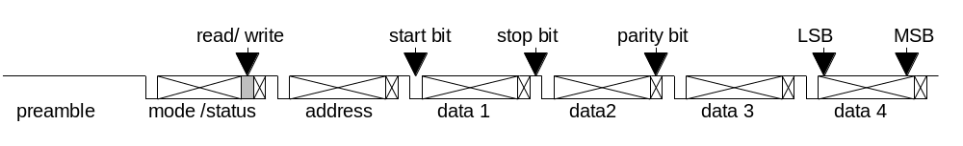
Fig. 6: Block structure of the serial communication streams.

Loop back, auto echo
Written data are echoed by the receiver byte by byte with start, parity and stop bits (not bit by bit!). This allows the sender to perform a check of the correct transmission.
A read request is not echoed. It is answered by the address of the requested data and the data itself. In the updated status byte, bit 6 is set. The writing of the answer can already begin while the transmission of the read request is still in progress (data bytes of the read request are not used, but checked!)
Every write or read cycle has to be terminated before starting a new one.

Data check, error detection
Every byte has to be checked with the parity bit. A detected parity error leads to abortion of the whole data by the receiver. After detecting a parity error the receiver will send a start bit only to the sender. After that the link goes to the idle state for at least 12 bits, respectively until it receives a new preamble. This sequence can be detected as a parity error together with a block end.
Data high for more than the length of the preamble (12 bits) within a block are interpreted as the begin of a new block. The incomplete block is discarded.
Data low for more than 30 bits are interpreted as a break of the link. In this case data block described in section 4.2.1is sent to the master.
An additional check can be done by the sender with the echoed data. Data sent after a read request can be verified with the parity check. This leads to a high reliability of the link.

Master slave structure
Though the communication has to be identical for both directions the EPICS VME crate shall be the master of the communication in the present.

Biphase modulation
To avoid distortions at high baud rates, caused by dc components in the signal, differential biphase level (Manchester encoding) is applied at the 5 MHz baud rate. (On the power supply this differential biphase level can be activated for every baud rate).

VHDL implementation – general comments

Serial data
Communication with the control system proceeds via optical fibres and runs at 5 MBaud. In addition, the standard frequency of 115.2 kHz as well as the two- four- and eightfold of that speed are selectable. Biphase- (Manchester-) modulation can be activated for every frequency. Modulation at 5 MHz is standard. (See Tab. 2 on how to select the different communication modes.)

 | CIO, ‘inv = ‘1’’ (standard) | CIO, ‘inv = ‘0’’ (non-standard) | RS232
Freq (kHz) | 115.2 / 230.8 / 461.6 / 923.2 / 5000 | 115.2 / 230.8 / 461.6 / 923.2 / 5000 | 115.2
‘Idle’ signal on link, no modulation | Light | Dark | High
‘Idle’ signal on link, modulated | Light-Dark | Dark-light | -
Startbit signal on link, no modulation | Dark | Light | Low
Startbit signal on link, modulated | Dark-light | Light-Dark | -
FPGA input signal / idle value / idle modulated | control_nRX / ‘0’ / ‘01’ | control_nRX / ‘1’ / ‘10’ | RS232_RX / ‘1’ / -
Synchronised signal / idle value / idle modulated | control_RX_60 / ‘1’ / ‘10’ | control_RX_60 / ‘1’ / ‘10’ | RS232_RX_30 / ‘1' / -
Manchester decoded input signal / idle value | dec_control_RX / ‘1’ | dec_control_RX / ‘1’ | - / ‘1’
Output signal before Manchester encoding is applied / idle value | dec_control_TX / ‘1’ | dec_control_TX / ‘1’ | RS232_TX / ‘1’
Encoded output signal / idle value / idle modulated | control_TX_int / ‘1’ / ‘10’ | control_TX_int / ‘1’ / ‘10’ | - / ‘1’
Output signal after inversion / idle value / idle modulated | control_TX / ‘1’ / ‘10’ | control_TX / ‘0’ / ‘01’ | RS232_TX / ‘1’
‘Idle’ signal on link, no modulation / modulated | Light / Light-Dark | Dark / Dark-Light | High / -
Table 5: Signal levels and selectable parameters on link and FPGA for the different inversion settings.

Block structure
On top of the byte-structure, communication proceeds via 6 byte blocks with the structure 'status byte - address byte - 4 data bytes'. Per default, every block received by the PSC is echoed by an according block - the status byte is updated and in case of read commands the requested data is sent. In case of write requests, the data bytes written to the PSC are simply echoed. The address is always echoed unless an illegal command to the FPGA was received. If any of the bytes of a block is received with wrong parity, the whole block is aborted and the echo stops indicating the error to the communication master. Echoing by the PSC can be suppressed, if the ‘echo on’ bit (see Tab. 2) is set to ‘0’.

Master function
The PSC acts as slave in the communication. It can be set to be master (only for the CIO channel, not for RS232), if the ‘PSC is master’ bit (see Tab. 2) is set to ‘1’. If this is the case, the DSP can write 32-bit data to the ‘Comm. Master Data’ address (see Tab. 1), followed by the 8-bit address byte, which is to be written to the ‘Comm. Master Addr’ address and which releases the sending of that block. Reading at the same address tells the DSP in master function, whether the sender is busy of not.

Write priority
While both channels can be used for reading in parallel, the writing-priority is assigned to only one of them at the time. If no PC is connected via the Dsub connector on the front panel of the controller card (RS232 unused, RS232_CHK low), write priority is always with the CIO. If the RS232 interface is connected to a PC through the appropriate cable, RS232_CHK is pulled high and the priority can be requested (only from the RS232 IF) by writing a ‘00000001’ to byte 3 address 2 (Priority RS232 in Tab. 1). Priority can be handed back to the CIO either by writing ‘0’ from the RS232 to the above address or by simply unplugging the Dsub connector. The CIO cannot influence the priority setting.

Address space seen from the serial links
Depending on their address, read and write commands access data on the FPGA or on the DSP. The address-space 0x0 to 0x3 seen from the serial links correspond to registers on the FPGA (see ), addresses 0x4 to 0xFF are not recognised by the FPGA but correspond to registers on the DSP where the subrange 0x04 to 0x1F is reserved for the parameters which can be written from the DSP to the FPGA and the address range 0x20 to 0x2F is reserved for commands to the monitor or user program. E.g. a read command to address 0x16 will not report the value of SYNC_PHASE_MIN used in the FPGA, but its mirrored value on the DSP (see sections 4.5.4 and 4.5.5).

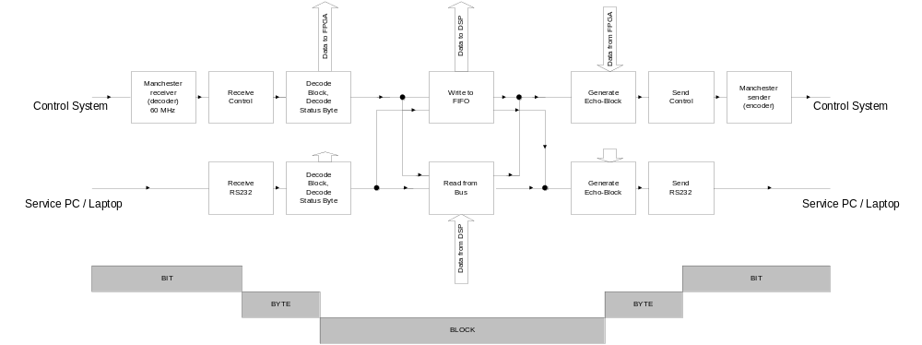
Fig. 7: Data flow serial communication. Serial bit-streams are received as bytes which are combined to blocks. When forming the answers, blocks are split into bytes which are transmitted bit by bit.

VHDL entities serial communication

Clock divider
All strobe signals necessary for the serial communications are obtained from dividing the 30/60 MHz clocks. Two versions of the clock-divider exist, clock_div_var (generates signals for varying transmission frequencies according to the set-up of the communication with the control system) and clock_div_rs232 (generates strobe signals for to 115.2 kHz only). Allowing much more flexibility, the variable frequency version of course occupies more resources of the FPGA and has therefore only been implemented for the communication with the control system.

Four steering signals are generate by the divider function:
- strobe_serial_send: Strobe, active once for 33.3 ns per bit to send.
- strobe_manchester: Active 10 or 12 times for 16.7 ns per bit.
- sync_serial_rec: Oversampling strobe, active 5 or 6 times (33.3 ns) per bit.
- mod_man: Modulation for manchester sender. The signal is high for half the time of a bit and low for the other half.

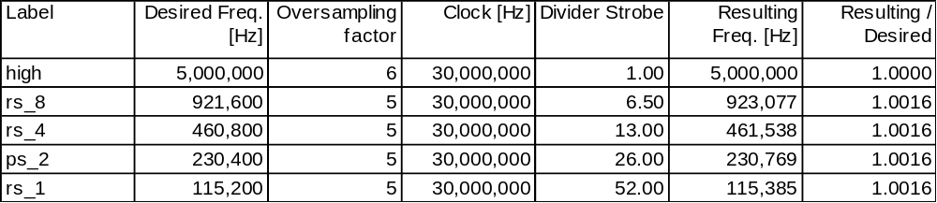
Tab. 6: Division factors for generating strobes of serial communication

For the 'high' case (5 MHz), six-fold oversampling can easily be achieved using the 30 MHz clock. If biphase modulation is used, the input data sampled at 60 MHz, allowing to have 6 samples of each of the two phases.

For the 'rs_1' case (115.2 kHz) five-fold oversampling can be done using an additional strobe active every 52 (=4*13) clock cycles. A bit therefore corresponds to 5*52=260 CC. To generate the mod_man signal, this time needs to be divided in two - one half of a cycle is 5*2*13=130 CC. All the other 'rs_x' cases are achieved similarly by further dividing all intervals by 2, 4 and 8 respectively. However it is obvious, that for the 'rs_4' and the 'rs_8' this is not possible within the given grid of the 30 MHz clock. A further division of the factor 13 into 4 more or less equally long sub-periods is done by an internal signal, which is active whenever the counter (running from 0 to 12) is at 0, 4, 7, and 10. In this way the 13 CC interval is split into one 4 CC and three 3 CC intervals. As for every external signal a series of these intervals is linked together, the differences in the duration of the sub-periods are averaged.
Most of the counters are implemented as state machines. Certain divisions are to be executed twice, once for the 30 MHz clock and once for the 60 MHz clock.

Synchronisation of input and reset, inversion of input or output
The incoming serial bit streams are synchronised once at 30 and once at 60 MHz (CIO only) in the entity sync_serial. In addition, inversions of the signals may be applied in this entity. The signal from the optical receiver is 'low', when light is being received. At the beginning of the development it was defined, that the idle state of the serial lines should correspond to 'high' and 'light on' (which would make it easy to distinguish between 'idle' and 'no connection to a sender'.) In this case, the input of the CIO has to be inverted. Using a standard RS232 to optical converter card, it was found that the idle state ('high') corresponds to 'dark'. In this case, the output rather then the input of the PSC has to be inverted which can be chosen setting the ‘inv’ bit as defined in Tab. 2 to ‘1’. (Be aware of the fact, that in this case a break of the optical connection cannot be distinguished from the line being idle.)
In addition to the input data the reset signal is synchronised in this process. This is done such, that an incoming reset is fed asynchronously to the entire FPGA. The transition of the reset signal to the passive ('1') state is done synchronous with the clock signal.
See Table 5.

Manchester decoder
In ref. [3] it was defined, that communication with the control system uses manchester encoding (‘biphase level’) in order to avoid DC effects, if the LED of the optical link is permanently on in case of no active communication. The implemented encoding uses the standard given in Tab. 7. A long sequence of logical ‘1’ (link idle) corresponds this way on the optical link to a digital signal oscillating at 5 MHz, avoiding DC effects.

Un-encoded signal | Duration per bit | Encoded signal | Duration per ‘half-bit’
‘1’ | 20 ns | ‘10’ | 10 ns
‘0’ | 20 ns | ‘01’ | 10 ns
Tab. 7: Manchester encoding: a logical one is encoded as the sequence of a logical one followed by a zero. A logical zero is encoded accordingly.
rec_manchester, the first logics element in the serial data stream 'de-modulates' the incoming biphase modulated data and generates serial data. The entity is only present in the CIO stream; if no modulation is needed (do_manchester is low), the data is simply fed through.
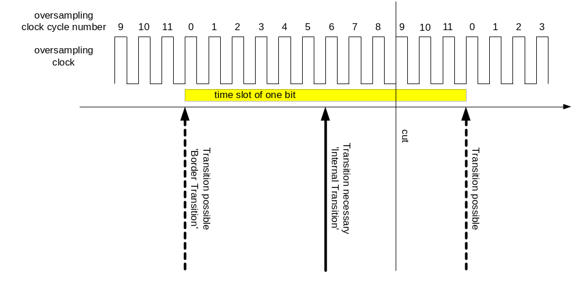
Fig. 8: A bit is 12 CC long, transitions may occur at start and end of the bit. In the centre of the bit, there is always an additional transition.

The idea behind the decoder is the following: One bit corresponds to 12 CC of the 60 MHz clock. By definition, there is always a transition of the input signal in the middle of the bits ('Internal Transition'), in addition there may be transitions at the beginning and at the end of the bits ('Border Transitions', depending on whether the un-encoded signal changes or not). To decode the input, we need to identify the transitions of the signals and count the number of clock cycles to the following transitions. Of course we first don't know, whether we start with a 'boarder transition' or with an 'internal' one. When starting with an internal transition, we always must see another transition after approximately 12 CC. If no transition follows after 12 +/- 2 CC, we know that we have started with a 'border transition' and therefore simply wait for the next transition which in turn must be an internal one.
According to the specification of the communication, not more then 9 zeroes may follow each other. If the counter starts on a wrong transition, it will misinterpret an idle-state of the sender as a sequence of zeroes instead of a series of ones. The number of decoded zeroes following each other is therefore counted and if it reaches 12, a phase shift of the decoder is done.
On the physical board, delays for falling and rising edges are different. If a transition occurs more then 9 CC after the start of the counter, it is considered as 1 entire bit later whereas earlier transitions are considered to be half a bit after the start. The maximal delay difference between rising and falling edges for which receiving works therefore is 2 CC i.e. 33ns (tested in simulation).
As the clocks of sender and receiver are of course only approximately synchronous, the counter does not turn over after 12 CC but is reset to zero by the detected transition.
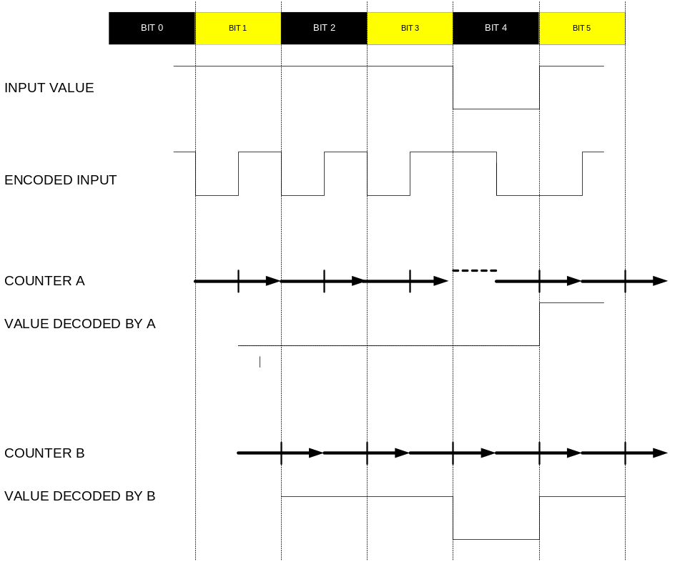
Fig. 9: Manchester Encoding: Input value and encoded signal. Two counters are started at different transitions for illustration of the decoding process: Counter A misfortunately starts on a 'border transition'. As the input value changes, there is no transition at the bit border and the phase of the counter is shifted by half a bit. Now both counters have the same phase and deliver correct output.

Serial receiver
The serial receiver can be used for 5-fold and for 6-fold oversampling. It consists of four processes:
- receiver: Main state machine according to the byte structure.
- counter_gen: Counter for oversampling strobes.
- strobe_gen: Generates the internally used sampling strobe once per bit.
- lat: Delays the output strobe 'newbyte_received' by one CC.
At reset, the state machine of the receiver is in the 'rxstartbit_state'. When the input data has the value 'STARTBIT', the receiving of a byte is started. As soon as the receiver is in the next state, the counter is enabled and will be incremented with every strobe - turn-over is after 5 or 6 strobes, depending on the selected oversampling factor. The sampling is controlled by the 'int_strobe' which is generated by the 'strobe_gen' process whenever the counter reaches the value of 2.
The selection between 5 fold and 6 fold oversampling is done by the signal five_fold which is determined in the entity clock_div_var from the selected transmission frequency. As for the receiver of the service interface (RS232) only five fold oversampling is necessary, the value of five_fold can be ignored in this instantiation of the receiver, which is implemented with the help of the generic constant ignore_five, which - somewhat confusing in the naming - selects five fold oversampling, ignoring the value of five_fold.

Serial sender
The serial sender consists of a state machine according to the structure of the bytes. No timing considerations are necessary here, everything is provided by the sync_serial_send strobe signal.
If the parity_ok signal goes low, this will be recorded by the signal do_rep_parity_ok which in turn is copied to rep_parity_ok when sending of a byte starts. do_rep_parity_ok is reset when transmission of a byte starts. If a parity error has been recorded before a byte is sent, only a startbit and 10 stopbits will be sent. 12 stopbits are required for this case in ref. [3]. There is no contradiction between this requirement and the implemented solution as after these 10 stopbits at least a preamble - maybe even more idle states - follow.
If the send_preamble bit is high, a preamble will be sent instead of a byte. The length of the preamble is adjustable by the constant Num_PREABITS. Keep in mind, that counting starts at 0.

Manchester encoder
Manchester encoding is very easy thanks to the mod_man signal which changes its value every half bit. As delay differences relative to the timing of the serial sender occur at the different possible frequencies, the serial input data is sampled once per bit, on the rising edge of mod_man.

Break- and preamble-detectors
Two special codes apart from the byte structures are defined for the communication:
- A BREAK of the optical link is detected, when no light is received for more than the duration of 30 bits. The entity break_detect is directly fed by the synchronized input data, before biphase decoding is applied. Keep in mind that a break can of course only be detected if the idle state of the communication differs from the signal which is received in the case of missing connections. This makes it impossible to detect breaks of the RS232 interface (where the signal RS232_CHK has been introduced to check whether a cable is connected to the card or not) or on the CIO if no biphase modulation is activated and the idle state is defined to be 'dark' (non-standard setting). Break detection is applied to the non-decoded (‘raw’) input signal.
- A PREAMBLE is detected, if the decoded value of the input stream is '1' for more than 12 bits and indicates that the communication link is presently idle. Preamble detection is applied to the decoded input signal.

VHDL entities handling communication blocks
The received bytes have to be combined to the defined block structure. Depending on the address and on whether it is a read or a write command, the requested echo has to be formed and commands to the FPGA have to be recognised and executed. This task has been split into the three entities as described in the following.

Decode block, count communication errors
block_decoder: recognises the structure of the block (preamble, status, address, 4*data) and generates a globally available signal (byte_id) which indicates the position of the last received byte to all other entities. In addition, deviations from the expected block structure are recognised as errors and all errors in the CIO are counted.
- par_err: parity error detected by the serial receiver.
- bre_err: break of the CIO input line.
- pre_err: 'preamble' or 'block structure error'. Occurs, if a preamble is received during an incompletely transmitted block or if more then 6 bytes are received without the necessary preamble in between.
- fifofu: 'FIFO full': the FIFO for data to be written to the DSP (see section 4.5.4) is full i.e. the DSP cannot cope with the amount of written data any more. The counter is incremented once when the FIFO is filled completely and does not count e.g. the number of additionally received words which could be stored any more.
It is of course possible, that one error is counted several times, e.g. a line break may be counted as 'brea', 'parity error' and as block structure error (preamble error) if the connection is interrupted during transmission of a block.

In addition to incrementing the error counter, flags are set in case of new errors, telling the DSP that its connection to the controlling system is not reliable:
- FLAG 8: 'NEW BREAK ERROR': The break signal has become active, i.e. no information from the CIO is received any more. This is a serious error.
- FLAG 9: 'NEW COMMUNICATION ERROR': any of the other error signals (preamble, parity or FIFOFU) went active. These errors should not be fatal.

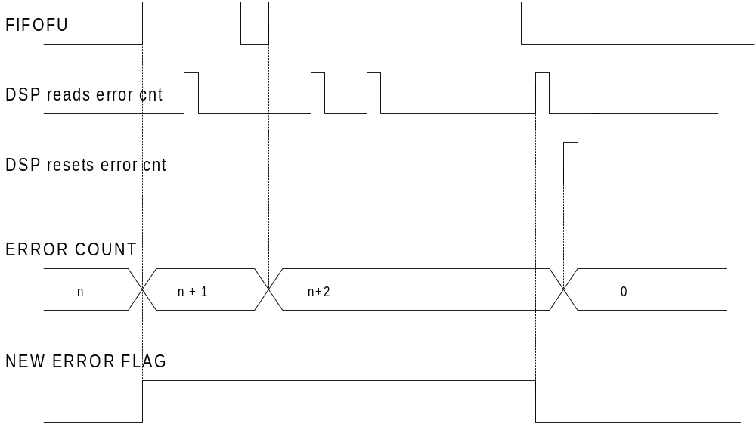

Figure 2: Reactions of error counters and new error flags to error signals and read / reset commands from the DSP.

Decode and update status byte
‘Status_decoder’:
- decodes the status byte, defines the variable read_command
- updates the status byte for the echo
- decodes in addition addresse byte and derives the signal echo_type (e.g. write_trigger or read_from_bus)
- executes commands to the FPGA (except trigger-signals from the serial IOs)

Generate echo
According to the received address and status bytes an echo has to be formed in gen_echo. Status and address are always received from the status decoder. The data bytes may originate from the status decoder (write commands), from some FPGA registers (read FPGA status) or from the BUS (read DSP register).
In every case, the transmission of the echo has to start as soon as possible:
- Write commands: transmission starts as soon as the status byte has been received. Every following byte is echoed, as soon as it is received. Note that in the case of short idle states between bytes in the incoming data stream (as observed in the case of communication with the serial port of a PC) these idle times have to be inserted in the outgoing data stream as well.
- Read FPGA status (address 0x0, 0x1, 0x3): transmission starts as soon as the address has been received.
- Read from DSP (address 0x4 to 0xFF): the FPGA sets up a DMA in the DSP as soon as the BUS is available. Transmission of the status byte of the echo starts as soon as the DMA has been executed and the requested data is available in the FPGA.
- Illegal commands: some addresses can only be read or written to (e.g. 0x0 can only be read). In case of an illegal request (e.g. write to 0x0), only the status byte and five bytes 0x00 are returned. This echo can be released as soon as the address has been received. Thanks to the address being set to 0x00, the controlling system can easily distinguish an illegal read command from the answer to any legal read, even in the case where all data bytes are zero occasionally.

According to the specification of the communication, we do not have to care about situations where some echo data of a read request - following the previous block too closely - might overwrite the not yet sent data of the previous block: a new block may only be sent by the controlling system, after the echo of the previous one has been received completely.
However in the case of read commands accessing data on the DSP at least the four resulting data bytes must be stored in this entity as soon as they are available: there is only one instantiation of the bus interface and as the two communication channels may read at the same time, the data from the bus interface may be valid only for a short time.
To make the structure clearer to understand, a record type mess_type_byte has been defined.

FIFO
To make optimal use of the resources on the ALTERA device, the 'MegaWizard Plug-in Manager' of the MAX+plus II program has been used to generate the FIFO (ad_fifo.vhd) needed for data which should be sent to the DSP. The chosen parameters are listed here:
- Width: 32 bits.
- Depth: 32 words (in fact we use 2 words per communication block which makes the FIFO 16 block deep.).
- Read and write are synchronised with one common clock.
- 'FULL' and 'EMPTY' flags are used.
- Asynchronous clear is available.
- Show-ahead synchronous FIFO mode is selected. (The data becomes available before 'rdreq' is asserted. 'rdreq' acts as a read acknowledge.)
- Default optimisation style.

The FIFO is instantiated in the entity FIFO_ctrl. As the FIFO does not make part of the LPM library the ALTERA program genmem.exe was used to get the according code for simulation (scfifo_16x32_sh.vhd). To distinguish between the two codes, they were given different names which makes it misfortunately necessary, to change the name of the instantiation depending on whether one wants to simulate or to synthesise/compile. The component declarations may stay in parallel.
With version 9.5 of Max+Plus II, the LPM_FIFO became available, which has been used to define the ad_lpm_fifo.vhd file. At the time this documentation was written, it was not yet clear whether that FIFO could be used instead and whether the simulation would become easier that way.
The received data is first collected in registers and only if the entire data block has been successfully received it is entered into the FIFO.

Bus interface
The following functionalities are implemented in the bus interface (bus_ctrl):
- Read from the FLASH (check valid firmware flag at start-up; only steering signals and addresses are generated here, data reading is in the system state machine)
- Host bus interface to DSP (set up DMA which transfers the data requested from the serial links to the FPGA)
- Serve read commands from the DSP
- Serve write commands from the DSP, which define parameters on the FPGA.

Reading from the FLASH
After a reset of the FPGA, the system state controller checks whether valid firmware is found in the FLASH. The address at which the magic number 0xDA is located (last address of sector 0) is reset value of to_bus_ad. The steering signals (nBMS and nRD and address) are provided from the bus controller which based on the present sys_state. All steering signals are applied for long enough such that the bus data can easily be compared to the expected value in the entity watchdog.

Host bus interface / set-up DMA
Read requests to the DSP cannot be answered by the FPGA by directly reading the according data from the DSP. A DMA of the DSP, writing the requested data to the FPGA, has to be started by the FPGA.
The FPGA can gain control of the local bus from the DSP using the Host Bus Interface (HBI). After the HB request from the FPGA, the DSP suspends all its bus actions and assert the HB granted signal. Now the FPGA is master on the bus and writes that data to the DSP, which is needed to execute the DMA. Next, FPGA gives back the control over the bus to the DSP which, as its first action, executes the DMA.

Serve read requests from DSP
Read requests on the FPGA are executed from the DSP using 2 wait states i.e. valid addresses and selection signals are applied to the FPGA for 100 ns. On the first CC the applied address is copied into a registered signal on the FPGA (from_bus_address), on the second clock the according information is available in a local variable (to_bus_data) and sent to the DSP in the third CC.

Serve write commands from DSP
Write commands from the DSP are the only situation where the timing was found to be critical on the bus: using DMAs and single access write commands from the user/monitor programs the time between two consecutive writes cannot be influenced. In some cases it was found that the not write strobe goes high for less then 10 ns and therefore cannot be detected by a synchronous process in the FPGA. A single process which is sensitive to the rising edges of nWR, toggling wr_toggle every time this happens, has been introduced therefore. The change of wr_toggle can in turn be recognised by a synchronous process where the data - as it was at the last rising edge of the clock - is copied into the according signal on the FPGA. Figure 3 shows the timing behaviour of the process.

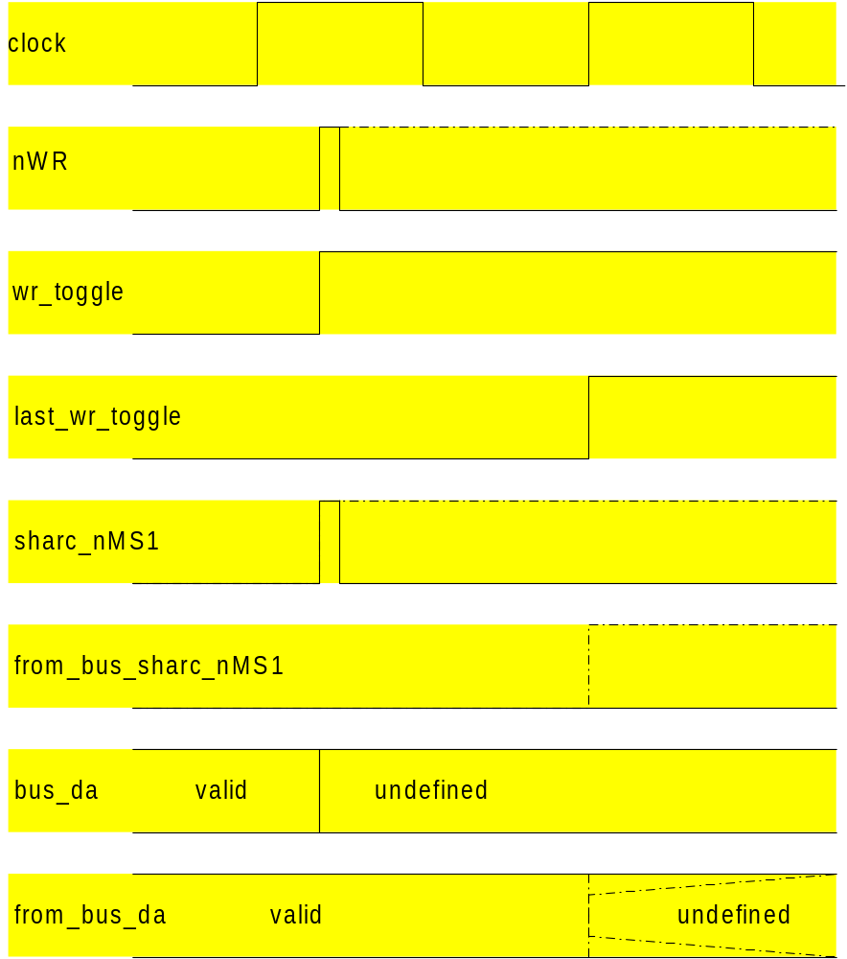

Figure 3: Timing of signals for write commands from the DSP, at the end of a single write command (dash-dotted line) and in the case where a second write command follows immediately after the first one (solid line). The figure follows the VHDL convention of not to show delta delays i.e. signal updates are shown without delay; equations evaluated at the rising edges of the clock take the values of the signals before that clock transition into account.
The rising edge of the nWR signal inverts the wr_toggle signal asynchronously. The value of wr_toggle is copied into last_wr_toggle on the rising edge of the clock and hence a difference between the two signals at the rising edge of the clock indicates that the nWR signal went high during the last clock cycle. The transition of the registered signal from_bus_sharc_nMS1 is delayed by 1 CC and in case of a immediately following next write it may even stay low. Data from the DSP is valid when the write strobe goes high and undefined thereafter. Data from the bus is copied into a register of the FPGA as long as the write strobe is low. This way, the register contains the data that was on the bus no more than 33 ns before, when the write strobe goes high. Using 2 wait states on the DSP side this procedure was found to be reliable.

Embedding PWM
The PWM has been programmed at PSI (M. Emmenegger) and the resulting VHDL code has been embedded here after only a few changes. All the necessary parameters can be seen in the port map of the entity TOP which contains instantiations of several sub entities.
Conversions of bit vectors as received from the local BUS to integers of different ranges (including bit-shifts according to Tab. 1) are implemented in the bus interface already.

FLASH controller
The entity FLASH_CTRL is an independent design which has to be loaded into the FPGA whenever the boot sector of the FLASH has to be erased or programmed. Using the RS232 interface, these operations can be controlled by the program VISUAL FLINK running on a PC (see Reference [6]).
The RS232 interface is identical to the one used in PS_CTRL. No block structure is put on top of the bytes. A simple interpreter is sensitive to two commands: sector erase (SE, 0x43) and program (P, 0xEF). Any other data byte is ignored by the command interpreter.
Having received a SE command, any address within the selected sector is expected. The FPGA then starts the erasing process on the FLASH, waits until the FLASH indicates the completion of that process and sends end signal (0x21) to the PC.
After a program command, the flash controller expects the number of bytes to be programmed, followed by the address where the first byte is to be written to. Every data byte, which follows, is written to the flash, read back and sent back to the PC. A consistency check is not done on the FPGA but on the PC where the whole data path (serial transmission to FPGA, writing into FLASH, reading from FLASH and serial transmission back to the PC) can be tested in one go. When writing into the boot sector (Monitor), the FLASH controller adds the valid firmware flag before returning to the command interpreter after having written the requested number of bytes. See Fig. 10 for the flow diagram of the FLASH controller, Fig. 11 shows the block diagram for the entities of the FLASH controller.
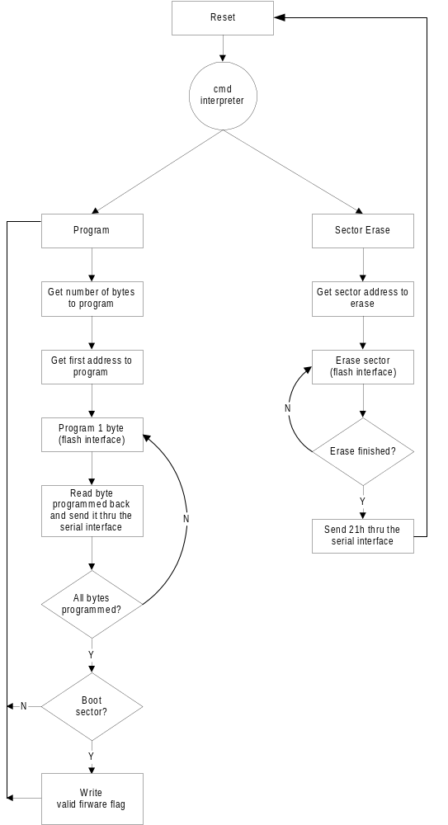
Fig. 10: Flow diagram of FLASH controller. See text for further explanations.
Figure 4

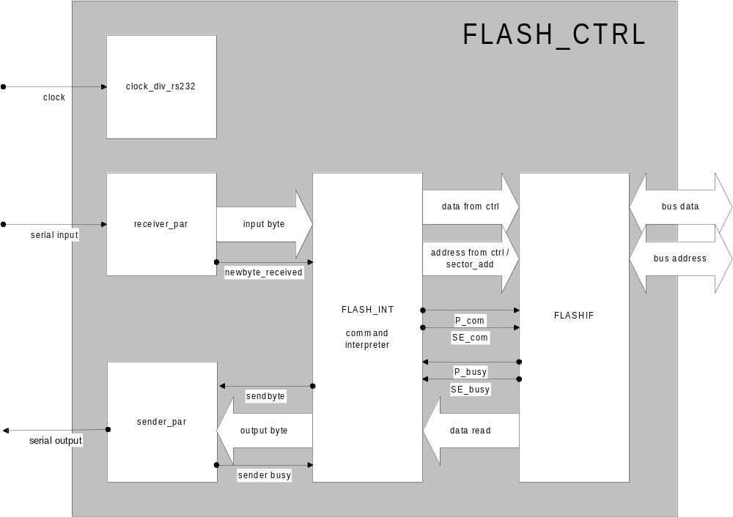
Fig. 11: Overview of the entity FLASH_CTRL with the main signals.

Test System
Two VHDL programs have been developed to run the test system for the PSC cards. These are described together with the according DSP and PC software in a separate document.

Synthetisation, Compilation Results
The VHDL code has been synthesised using Synplify; different revisions up to version 5.31 have been used.
The following constraint files have been used and delivered to PSI:
- PS_CTRL_256.sdc (For using a 256 pin FineLine PBA package as populated on the series delivered by SCS in 1999 and 2000)
- PS_CTRL_484.sdc (In case a larger device in the 484 pin FineLine BGA package is used in the future.)
The following Synplify project files contain lists the different files used in the according designs:
- PS_CTRL.prj
- FLASH_CTRL.prj
- TEST_CTRL.prj
- TEST_MASTER.prj

For compilation Max+Plus II version 9.5 has been used, where 38 MHz have been reached for the system clock (running at 30 MHz on the board) and 86 MHz for the oversampling clock (running at 60 MHz on the board) (Version 20 of the VHDL code).
The following options have been assigned (Assign-menu of Max+Plus II – Assignment boxes not mentioned here have been left empty):
- Device: defined in Synplify constraint file.
- Pins: defined in Synplify constraint file.
- Clock: defined in Synplify constraint file.
- Cliques: defined in Synplify constraint file (Perform cliquing in Synplify).

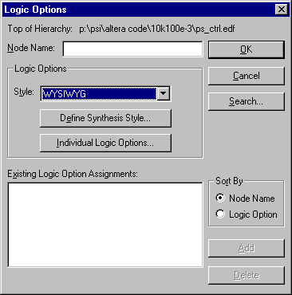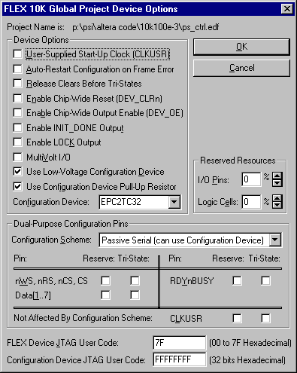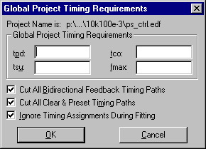

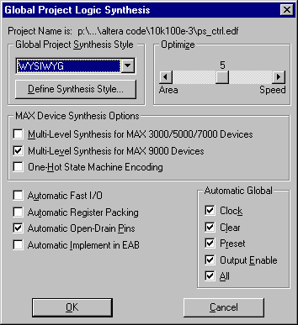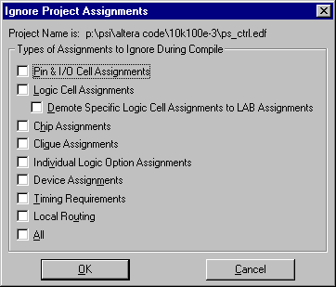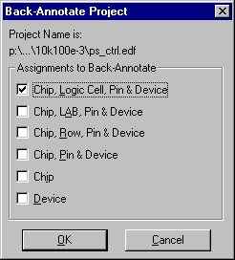
Fig. 12: Settings in different windows available under the ‚Assignments’ menu.

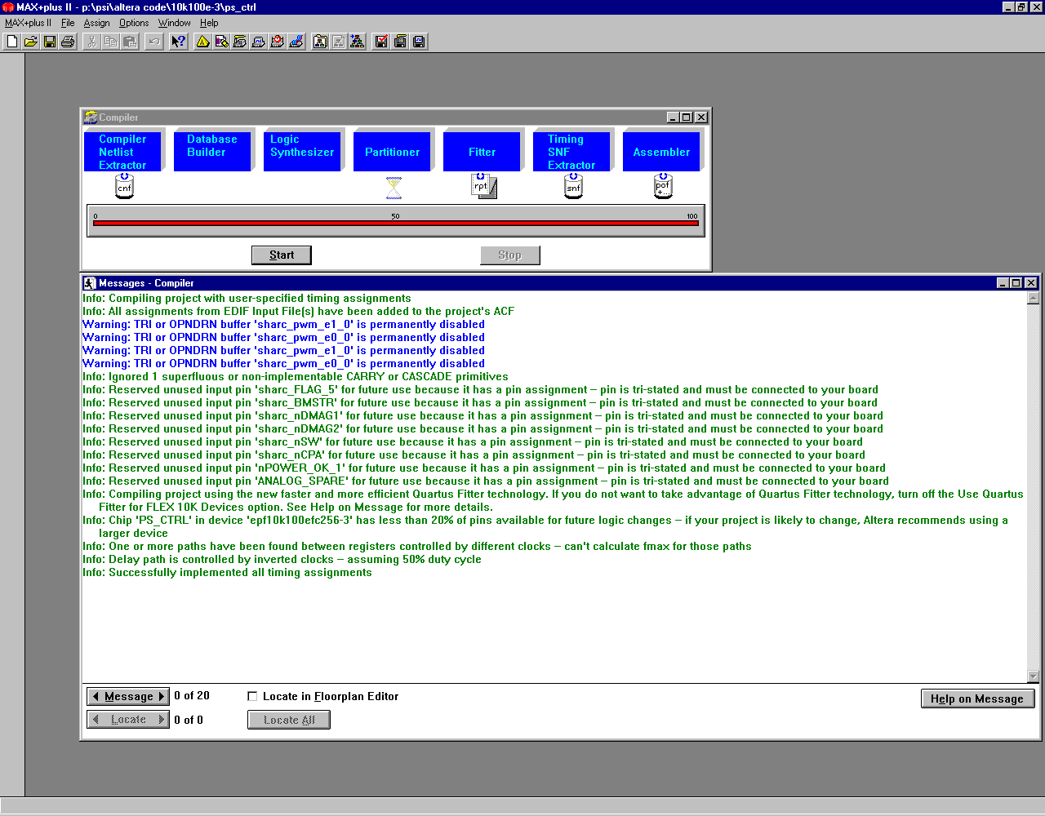
Fig. 13: Output from the compilation with MAX+Plus II v 9.5

A complete report file of compilation is included on the documentation CD, the more interesting parts are repeated here:

** DEVICE SUMMARY **

Chip/ Input Output Bidir Memory Memory LCs
POF Device Pins Pins Pins Bits % Utilized LCs % Utilized

PS_CTRL
epf10k100efc256-3 61 63 40 1024 2 % 3213 64 %

User Pins: 61 63 40

. . .

Device: epf10k100efc256-3

FLEX 10K Configuration Scheme: Passive Serial

Device Options:
User-Supplied Start-Up Clock = OFF
Auto-Restart Configuration on Frame Error = OFF
Release Clears Before Tri-States = OFF
Enable Chip_Wide Reset = OFF
Enable Chip-Wide Output Enable = OFF
Enable INIT_DONE Output = OFF
JTAG User Code = 7f
MultiVolt I/O = OFF

. . .

A1 ^DATA0 E1 sharc_FLAG_3 J1 RESERVED N1 bus_addr23
A2 RESERVED E2 sharc_nIRQ0 J2 bus_addr3 N2 sharc_nRESET
A3 PWM_RFS E3 RESERVED J3 bus_addr19 N3 spare6
A4 ANALOG_CLK E4 RESERVED J4 bus_addr20 N4 ^nCONFIG
A5 PWM_O0 E5 GND J5 bus_addr0 N5 bus_addr13
A6 PWM_FB2 E6 VCCIO J6 VCCIO N6 bus_addr14
A7 PWM_FB1 E7 sharc_nDMAR1 J7 VCCINT N7 bus_data29
A8 nDIG_I_2 E8 GND J8 GND N8 sharc_nBMS
A9 clock_over E9 nDIG_I_01 J9 GND N9 sharc_nMS2
A10 sharc_nHBR E10 nDIG_I_4 J10 VCCINT N10 RS232_CHK
A11 DIG_O1 E11 VCCINT J11 VCCINT N11 bus_data20
A12 nTRIGGER_2 E12 GND J12 bus_data1 N12 VCCIO
A13 DIG_O0 E13 sharc_REDY J13 bus_data0 N13 reset_ext
A14 nDIG_I_03 E14 nDIG_I_3 J14 sharc_FLAG_9 N14 bus_data12
A15 nDIG_I_02 E15 sharc_nSW J15 sharc_nRD N15 RESERVED
A16 sharc_BMSTR E16 RESERVED J16 bus_data2 N16 bus_data11
B1 ^nCE F1 sharc_FLAG_2 K1 bus_addr6 P1 ^MSEL0
B2 ^DCLK F2 spare1 K2 bus_addr4 P2 bus_addr16
B3 ANALOG_SPARE F3 RESERVED K3 RESERVED P3 nTRIGGER_3
B4 PWM_O1 F4 RESERVED K4 bus_addr9 P4 bus_addr15
B5 PWM_O5 F5 VCCINT K5 bus_addr5 P5 spare7
B6 PWM_FB5 F6 GND K6 VCCIO P6 sharc_FLAG_7
B7 PWM_FB0 F7 VCCINT K7 GND P7 control_TX
B8 nTRIGGER_1 F8 VCCIO K8 VCCIO P8 bus_data28
B9 GND F9 VCCINT K9 VCCINT P9 bus_data24
B10 nPWM_SYNC_I F10 VCCIO K10 GND P10 bus_data21
B11 sharc_nDMAG2 F11 GND K11 VCCIO P11 bus_data19
B12 nDIG_I_13 F12 VCCINT K12 bus_data6 P12 bus_data17
B13 sharc_nHBG F13 sharc_nCPA K13 bus_data7 P13 RESERVED
B14 DIG_O6 F14 nPOWER_OK_0 K14 RESERVED P14 bus_data14
B15 #TCK F15 nPOWER_OK_1 K15 bus_data3 P15 #TMS
B16 ^nCEO F16 nDIG_I_06 K16 RESERVED P16 bus_data4
C1 sharc_nIRQ2 G1 sharc_FLAG_0 L1 bus_addr8 R1 ^MSEL1
C2 #TDI G2 sharc_FLAG_1 L2 RESERVED R2 VCCINT
C3 PWM_O2 G3 RESERVED L3 bus_addr12 R3 spare4
C4 PWM_O4 G4 RESERVED L4 RESERVED R4 spare3
C5 ANALOG_SOC_1 G5 RESERVED L5 VCCINT R5 sharc_FLAG_5
C6 sharc_PWM_E1 G6 VCCIO L6 GND R6 sharc_FLAG_6
C7 PWM_FB4 G7 GND L7 VCCINT R7 bus_data30
C8 nTRIGGER_0 G8 VCCIO L8 clock R8 GND
C9 DIG_O2 G9 GND L9 VCCINT R9 nRESET_FLASH
C10 nDIG_I_11 G10 GND L10 VCCIO R10 bus_data23
C11 sharc_nDMAG1 G11 VCCIO L11 GND R11 RS232_TX
C12 nDIG_I_00 G12 nDIG_I_05 L12 VCCINT R12 bus_data18
C13 sharc_nCS G13 sharc_ACK L13 bus_data13 R13 bus_data16
C14 DIG_O7 G14 nDIG_I_10 L14 bus_data9 R14 LED2
C15 ^CONF_DONE G15 nDIG_I_04 L15 bus_data8 R15 LED1
C16 #TDO G16 RESERVED L16 sharc_nMS0 R16 #TRST
D1 RESERVED H1 RESERVED M1 bus_addr7 T1 bus_addr18
D2 sharc_nIRQ1 H2 bus_addr2 M2 bus_addr22 T2 bus_addr17
D3 PWM_SYNC_O H3 bus_addr1 M3 bus_addr10 T3 spare2
D4 PWM_O3 H4 bus_addr21 M4 bus_addr11 T4 control_nRX
D5 ANALOG_SOC_0 H5 spare0 M5 GND T5 sharc_FLAG_4
D6 sharc_PWM_E0 H6 VCCINT M6 VCCIO T6 spare5
D7 PWM_FB3 H7 VCCINT M7 sharc_nWR T7 bus_data31
D8 DIG_O3 H8 GND M8 bus_data26 T8 GND
D9 sharc_nDMAR2 H9 GND M9 GND T9 bus_data27
D10 nDIG_I_12 H10 VCCINT M10 bus_data22 T10 bus_data25
D11 sharc_nSBTS H11 VCCIO M11 VCCINT T11 RS232_RX
D12 VCCIO H12 sharc_nMS3 M12 GND T12 LED3
D13 DIG_O4 H13 sharc_FLAG_8 M13 sharc_nMS1 T13 bus_data15
D14 DIG_O5 H14 sharc_FLAG_11 M14 RESERVED T14 LED_0
D15 nDIG_I_6 H15 sharc_FLAG_10 M15 bus_data10 T15 bus_data5
D16 nDIG_I_5 H16 RESERVED M16 RESERVED T16 ^nSTATUS

N.C. = No Connect. This pin has no internal connection to the device.
VCCINT = Dedicated power pin, which MUST be connected to VCC (2.5 volts).
VCCIO = Dedicated power pin, which MUST be connected to VCC (2.5 volts).
GND = Dedicated ground pin or unused dedicated input, which MUST be connected to GND.
RESERVED = Unused I/O pin, which MUST be left unconnected.

^ = Dedicated configuration pin.
+ = Reserved configuration pin, which is tri-stated during user mode.
* = Reserved configuration pin, which drives out in user mode.
PDn = Power Down pin.
@ = Special-purpose pin.
# = JTAG Boundary-Scan Testing/In-System Programming or Configuration Pin. The JTAG inputs TMS and TDI should be tied to VCC and TCK should be tied to GND when not in use.
& = JTAG pin used for I/O. When used as user I/O, JTAG pins must be kept stable before and during configuration. JTAG pin stability prevents accidental loading of JTAG instructions.
$ = Pin has PCI I/O option enabled. Pin is neither '5.0 V'- nor '3.3 V'-tolerant.

. . .

Total dedicated input pins used: 2/6 ( 33%)
Total I/O pins used: 162/185 ( 87%)
Total logic cells used: 3213/4992 ( 64%)
Total embedded cells used: 32/192 ( 16%)
Total EABs used: 2/12 ( 16%)
Average fan-in: 2.71/4 ( 67%)
Total fan-in: 8737/19968 ( 43%)

Total input pins required: 61
Total input I/O cell registers required: 0
Total output pins required: 63
Total output I/O cell registers required: 0
Total buried I/O cell registers required: 0
Total bidirectional pins required: 40
Total reserved pins required 0
Total logic cells required: 3213
Total flipflops required: 1727
Total packed registers required: 0
Total logic cells in carry chains: 656
Total number of carry chains: 68
Total number of carry chains of length 1-8 : 50
Total number of carry chains of length 9-16: 6
Total number of carry chains of length 17-24: 4
Total number of carry chains of length 25-32: 8
Total logic cells in cascade chains: 488
Total number of cascade chains: 200
Total single-pin Clock Enables required: 0
Total single-pin Output Enables required: 0
Logic cells inserted for fitting: 3

Synthesized logic cells: 35/4992 ( 0%)

Testing

Testbenches
Testbenches have been written for the following entities (whereas testbenches for entities other then the top-layers of the design have not been kept up to date):
- ps_ctrl_tb.vhd: Testbench to top layer of PS_CTRL. Includes sharc_tb and some of the entities used in the code which is synthesised.
- rec_pwm_fb_tb.vhd: Testbench which was used to test the entity rec_pwm_fb. (switch internal feedback signals only to low=alarm, if external signals stay low for a certain time).
- watchdog_tb.vhd: Testbench for the interplay of entities watchdog and trigger_ctrl.
- tb_rs232.vhd: Serial communication for the RS232 stream.
- tb_serial.vhd: Same as previous, but for CIO.
- tb_bus_if.vhd: Test bus interface, including simultaneous read commands from RS232 and CIO.
- sharc_tb.vhd: Simulate DSP (used in ps_ctrl_tb and tb_bus_if).
- tb_fifo_ctrl.vhd: Test behaviour of FIFO lpm.
- tb_para.vhd: Block communication part for one channel, without serial part (simulation is much simpler and faster this way).
- flash_ctrl_tb.vhd: Simulate FLASH controller.
- top_tb.vhd: Check behaviour of PWM.
- test_ctrl_tb.vhd: Used to develop code for testing the cards (see section 6).
- sharc_tester_tb.vhd: Simulates DSP, mentioned above.

References
- Feasibility Study, SCS, January 1999.
- Specification, SCS & PSI, 10.3.1999
- Memorandum, PSI 10.2.1999 and Completion, PSI, 31.3.1999
- System Design PSI-DSP SW
- System Design PSI-DSP HW
- PSI-DSP - Software tools

This part has been developed by PSI and is not documented here.
This byte is written into the FLASH after successful loading of a monitor-program. If it is missing, the DSP is kept in RESET. The 'valid firmware-byte' has the value 0xDA and is located at address 0x00FFFF i.e. at the last address of sector 0 of the FLASH.
For simplicity, the numbers for the 5MHz case (2*6 fold oversampling) are used explicitly here
4-byte sequence, starting with the least significant byte.

